Blow molding
Blow molding is a manufacturing process that is used to create hollow plastic parts by inflating a heated plastic tube until it fills a mold and forms the desired shape. The raw material in this process is a thermoplastic in the form of small pellets or granules, which is first melted and formed into a hollow tube, called the parison. There are various ways of forming the parison. The parison is then clamped between two mold halves and inflated by pressurized air until it conforms to the inner shape of the mold cavity. Lastly, after the part has cooled, the mold halves are separated and the part is ejected.
Parts made from blow molding are plastic, hollow, and thin-walled, such as bottles and containers that are available in a variety of shapes and sizes. Small products may include bottles for water, liquid soap, shampoo, motor oil, and milk, while larger containers include plastic drums, tubs, and storage tanks. Blow molded parts can be formed from a variety of thermoplastic materials, including the following:

- Low Density Polyethylene (LDPE)
- High Density Polyethylene (HDPE)
- Polyethylene Terephtalate (PET)
- Polypropylene (PP)
- Polyvinyl Chloride (PVC)
There are three principal techniques of Blow Molding, differing in the method by which parisons are prepared:
- Extrusion Blow Molding
- Injection Blow Molding
- Stretch Blow Molding

REF: http://ns-plastic.blogspot.com/2011/01/types-of-blow-molding-process.html

Extrusion Blow Molding
Extrusion Blow Molding involves manufacture of parison by conventional extrusion method using a die similar to that used for extrusion pipes.
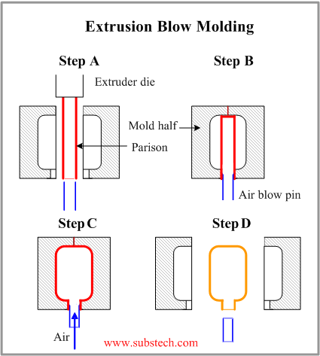
Extrusion Blow Molding is commonly used for mass production of plastic bottles.
The production cycle consists of the following steps:
- The parison is extruded vertically in downward direction between two mold halves.
- When the parison reaches the required length the two mold halves close resulting in pinching the top of parison end and sealing the blow pin in the bottom of the parison end.
- Parison is inflated by air blown through the blow pin, taking a shape conforming that of the mold cavity. The parison is then cut on the top.
- The mold cools down, its halves open, and the final part is removed.

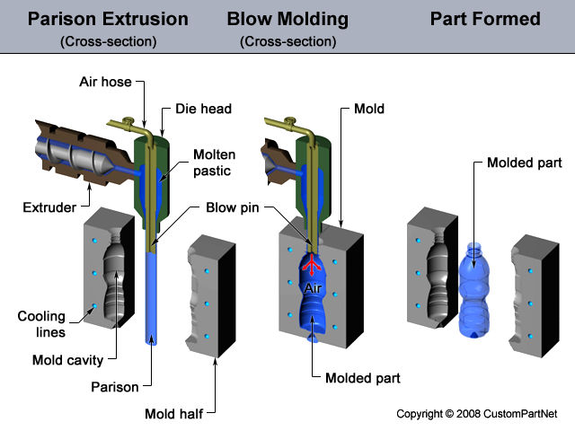

Injection Blow Molding
- In Injection Blow Molding method, a parison is produced by injecting a polymer into a hot injection mold around a blow tube or core rod.
- Then the blow tube together with the parison is removed from the injection mold and transferred to a blow mold.
- Air is injected under pressure blowing the polymer against the mold walls where it cools and freezes as with extrusion blow molding.

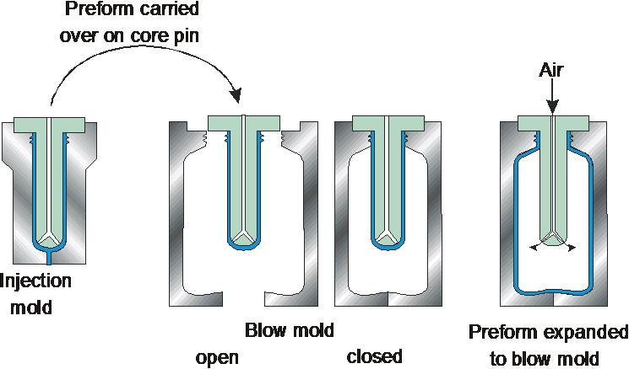

*Injection Blow Molding is a more accurate and controllable process as compared to the Extrusion Blow Molding.
*It allows producing more complicated products from a wider range of polymer materials.

*However production rate of Injection Blow Molding method is lower than that of Extrusion Blow Molding.

Stretch Blow Molding
Stretch Blow Molding involves injection molding of a parison, which is then stretched in the downward direction by means of the blow tube.
In this method biaxial molecular orientation is produced. The specific molecular orientation provides higher mechanical strength, rigidity and transparency of the material. That is why this method is used for manufacturing containers for carbonated beverages.
Material, commonly used in this method is Polyethylene Terephtalate (PET).
