Metals, Nonmetals and Metalloids

Elements of the periodic table are grouped as metals, metalloids or semimetals, and nonmetals.

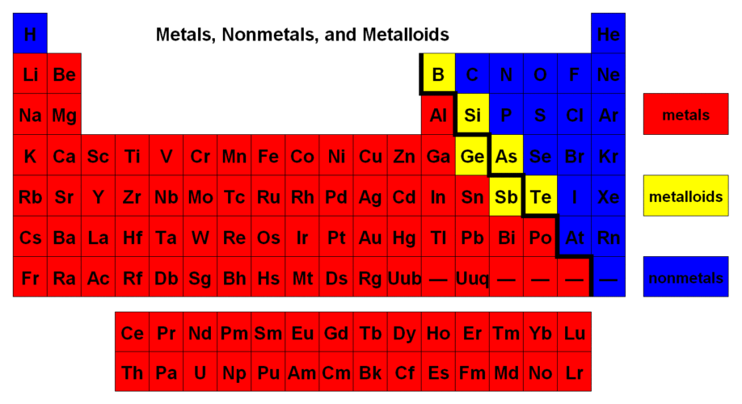
Metals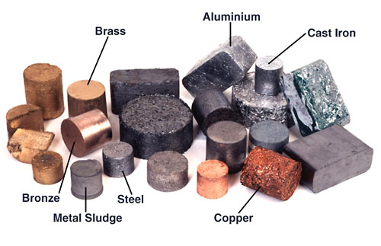 | Nonmetals  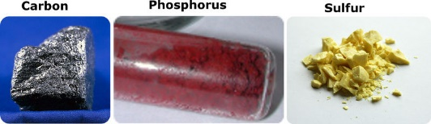 | Metalloids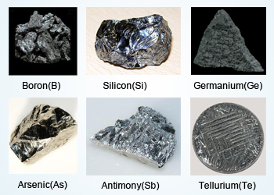

Metals

Physical Properties of Metals:
- State: Metals are solids at room temperature with the exception of mercury, which is liquid at room temperature (Gallium is liquid on hot days).
- Luster: Metals are lustrous; they have the quality of reflecting light from its surface and can be polished e.g., gold, silver and copper.
- Malleability: Metals are malleable; they have the ability to withstand hammering and can be made into thin sheets known as foils (a sugar cube chunk of gold can be pounded into a thin sheet which will cover a football field).
- Ductility: Metals are ductile; they can be drawn into wires. 100 gm of silver can be drawn into a thin wire about 200 meters long.
- Hardness: All metals are hard except sodium and potassium, which are soft and can be cut with a knife.
- Valency: Metals have 1 to 3 electrons in the outermost shell of their atoms.
- Conduction: Metals are good conductors because they have free electrons. Silver and copper are the two best conductors of heat and electricity. Lead is the poorest conductor of heat. Bismuth, mercury and iron are also poor conductors.
- Density: Metals have high density and are very heavy. Iridium and osmium have the highest densities where as lithium has the lowest density.
- Melting and Boiling Points: Metals have high melting and boiling point. Tungsten has the highest melting point where as silver has low boiling point. Sodium and potassium have low melting points.

Chemical Properties of Metals:
- Electropositive Character: Metals tend to have low ionization energies, and typically lose electrons (i.e. are oxidized) when they undergo chemical reactions. They normally do not accept electrons.
- Compounds of metals with non-metals tend to be ionic in nature.
- Most metal oxides are basic oxides and dissolve in water to form metal hydroxides.

Nonmetals

Physical Properties of nonmetals:
- Physical State: Non-metals can be gaseous, liquids or solids. Most of the non-metals exist in two of the three states of matter at room temperature: gases (oxygen) and solids (carbon).
- Non-Malleable and Ductile: Non-metals are very brittle, and cannot be rolled into wires or pounded into sheets.
- Conduction: They are poor conductors of heat and electricity (except graphite).
- Luster: They are non-lustrous; they have no metallic luster and do not reflect light.
- Melting and Boiling Points: The melting points of non-metals are generally lower than metals.
- Seven non-metals exist under standard conditions as diatomic molecules: H₂(g), N₂(g), O₂(g), F₂(g), Cl₂(g), Br₂(l), I₂(l) (volatile liquid - evaporates readily)

Chemical Properties of Nonmetals
- Non-metals have a tendency to gain or share electrons with other atoms. They are electronegative in character.
- Nonmetals, when reacting with metals, tend to gain electrons and become anions.
- Compounds composed entirely of nonmetals are molecular substances (not ionic).
- They generally form acidic oxides with oxygen that dissolve in water react to form acids.

Metalloids

Properties intermediate between the metals and nonmetals. Metalloids are useful in the semiconductor industry.

Physical Properties of Metalloids
- State: They are all solid at room temperature.
- Conduction: Some metalloids, such as silicon and germanium, can act as electrical conductors under the right conditions, thus they are called semi-conductors.
- Luster: Silicon for example appears lustrous, but is not malleable or ductile (it is brittle - a characteristic of some nonmetals). It is a much poorer conductor of heat and electricity than the metals.
- Solid Solutions: They can form alloys with other metals. *An alloy is a mixture of metals or a mixture of a metal and another element. An alloy may be a solid solution of metal elements (a single phase) or a mixture of metallic phases (two or more solutions).

Chemical Properties of Metalloids
- Their physical properties tend to be metallic, but their chemical properties tend to be non-metallic.
- The oxidation number of an element in this group can range from +3 to -2, depending on the group in which it is located.
Types of Bonding

When elements combine to form compounds, there are two major types of bonding that can result. Ionic bonds form when there is a transfer of electrons from one species to another, producing charged ions which attract each other very strongly by electrostatic interactions, and covalent bonds, which result when atoms share electrons to produce neutral molecules. In general, metal and nonmetals combine to form ionic compounds, while nonmetals combine with other nonmetals to form covalent compounds (molecules).

Since the metals are further to the left on the periodic table, they have low ionization energies and low electron affinities, so they lose electrons relatively easily and gain them with difficulty. They also have relatively few valence electrons, and can form ions (and thereby satisfy the octet rule) more easily by losing their valence electrons to form positively charged cations.

Nonmetals are further to the right on the periodic table, and have high ionization energies and high electron affinities, so they gain electrons relatively easily, and lose them with difficulty. They also have a larger number of valence electrons, and are already close to having a complete octet of eight electrons. The nonmetals gain electrons until they have the same number of electrons as the nearest noble gas (Group 8A), forming negatively charged anions.

Ionic compounds are held together in a regular array called a crystal lattice by the attractive forces between the oppositely charged cations and anions. These attractive forces are very strong, and most ionic compounds therefore have very high melting points. (For instance, sodium chloride, NaCl, melts at 801°C, while aluminum oxide, Al₂O₃, melts at 2054°C.) Ionic compounds are typically hard, rigid, and brittle. Ionic compounds do not conduct electricity, because the ions are not free to move in the solid phase, but ionic compounds can conduct electricity when they are dissolved in water.

When nonmetals combine with other nonmetals, they tend to share electrons in covalent bonds instead of forming ions, resulting in the formation of neutral molecules.

When metals combine with each other, the bonding is usually described as metallic bonding. In this model, each metal atom donates one or more of its valence electrons to make an electron sea that surrounds all of the atoms, holding the substance together by the attraction between the metal cations and the negatively charged electrons. Since the electrons in the electron sea can move freely, metals conduct electricity very easily, unlike molecules, where the electrons are more localized.

Metal atoms can move past each other more easily than those in ionic compounds (which are held in fixed positions by the attractions between cations and anions), allowing the metal to be hammered into sheets or drawn into wire. Different metals can be combined very easily to make alloys, which can have much different physical properties from their constituent metals. Steel is an alloy of iron and carbon, which is much harder than iron itself; chromium, vanadium, nickel, and other metals are also often added to iron to make steels of various types. Brass is an alloy of copper and zinc which is used in plumbing fixtures, electrical parts, and musical instruments. Bronze is an alloy of copper and tin, which is much harder than copper.

