CHEMISTRY

Chemistry is the "scientific study of matter, its properties, and interactions with other matter and with energy".

Matter is anything that has mass and occupies space. It can exist in one of three classic states: solid, liquid, and gas. When a substance goes from one state of matter to another, the process is called a change of state or phase change.

Solid, liquid, and gas
A solid has a definite shape and occupies a definite volume. The particles that make up the solid are very close together and aren’t moving around very much. That’s because in many solids, the particles are pulled into a rigid, organized structure of repeating patterns called a crystal lattice.

Unlike solids, liquids have no definite shape; however, they do have a definite volume, just like solids do. The particles in liquids are much farther apart than the particles in solids, and they’re also moving around much more. The attractive forces among the particles aren’t as strong as they are in solids, which is why liquids don’t have a definite shape. However, these attractive forces are strong enough to keep the substance confined in one large mass — a liquid — instead of going all over the place.

A gas has no definite shape and no definite volume. In a gas, particles are much farther apart than they are in solids or liquids, and they’re moving relatively independent of each other. Because of distance between the particles and the independent motion of each of them, the gas expands to fill the area that contains it (and thus it has no definite shape).

Phase Change: There are six distinct changes of phase which happens to different substances at different temperatures. The six changes are:
- Freezing: the substance changes from a liquid to a solid.
- Melting: the substance changes from a solid to a liquid.
- Condensation: the substance changes from a gas to a liquid.
- Vaporization: the substance changes from a liquid to a gas.
- Sublimation: the substance changes directly from a solid to a gas without going through the liquid phase.
- Deposition: the substance changes directly from a gas to a solid without going through the liquid phase.
Pure Substances and Mixtures
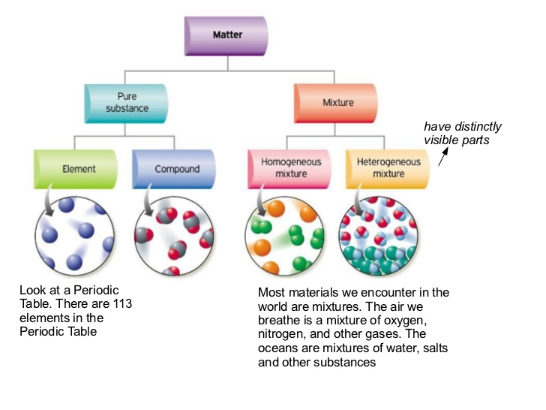
A pure substance, like salt or sugar, has a uniform composition throughout a given sample and from one sample to another. A pure substance can be either an element or a compound.
An element is composed of a single type of atom. Elements cannot be decomposed into simpler substances, not by heating, crushing, exposure to acids, and so on. About 90 of the elements can be extracted from natural sources, the rest must be created through nuclear processes. The important thing to remember right now is that elements are the building blocks of matter.
A compound is composed of two or more elements in a specific ratio. For many compounds we can isolate the smallest identifiable unit of a compound. We call it a molecule. For example, water (H2O) is a compound made up of two elements, hydrogen (H) and oxygen (O). A molecule of water consists of two hydrogen atoms joined to a single oxygen atom. Compounds retain their identities during physical changes but can be separated into their component elements by appropriate chemical changes.
Mixtures are physical combinations of pure substances that have no definite or constant composition; the composition of a mixture varies according to whoever prepares the mixture. Each component of the mixture retains its own set of physical and chemical characteristics.

Mixtures can be either homogeneous or heterogeneous:

Homogeneous mixtures have uniform compositions and physical properties throughout a given sample but that vary from one sample to another. They are sometimes called solutions. If you dissolve sugar in water and mix it really well, your mixture is basically the same no matter where you sample it.
Heterogeneous mixtures: The composition and physical properties of heterogeneous mixtures vary from one part of the mixture to another. For instance, if you put some sugar in a jar, add some sand, and then give the jar a couple of shakes, your mixture doesn’t have the same composition throughout the jar. Because the sand is heavier, there’s probably more sand at the bottom of the jar and more sugar at the top.

Physical and Chemical Properties
Physical properties can be observed or measured without changing the composition of matter. Some examples of physical properties are: physical state (solid, liquid or gas at certain temperatures and pressures), colour, odor, solubility in water, density, melting point, boiling point, hardness, ductility, hardness, malleability (gold and silver are highly malleable), and conductivity.
(In materials science, ductility is a solid material's ability to deform under tensile stress; this is often characterized by the material's ability to be stretched into a wire. Malleability, a similar property, is a material's ability to deform under compressive stress; this is often characterized by the material's ability to form a thin sheet by hammering or rolling).
Properties that describe how a substance changes into a completely different substance are called chemical properties. A chemical change alters the composition of the original matter. Flammability, reactivity, corrosion, oxidation are examples of chemical properties.
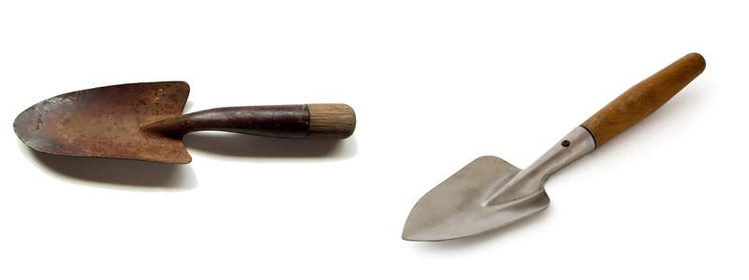
Look at the two garden trowels pictured here. Both trowels were left outside for several weeks. One tool became rusty, but the other did not. The tool that rusted is made of iron, and the other tool is made of aluminum. The ability to rust is a chemical property of iron but not aluminum.

Chemical Reactions
Chemical reactions occur when chemical bonds between atoms are formed or broken. The substances that go into a chemical reaction are called the reactants (usually shown on the left side of a chemical equation), and the substances produced at the end of the reaction are known as the products (usually found on the right side of a chemical equation). An arrow is often drawn between the reactants and products to indicate the direction of the chemical reaction. For example, hydrogen gas (H2) can react with oxygen gas (O2) to form water (H20). The chemical equation for this reaction is written as:
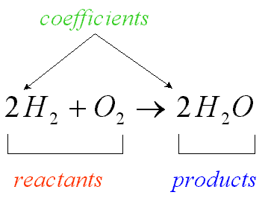 | 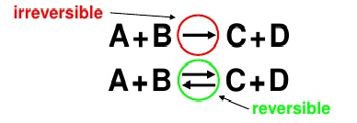

Some chemical reactions proceed in one direction until the reactants are used up and are said to be irreversible. Reversible reactions, on the other hand, can go in both forwards and backwards directions. In a reversible reaction, reactants turn into products, but products also have the capacity to turn back into reactants.

