Extrusion of polymers
A principal scheme of an extruder is shown in the picture.

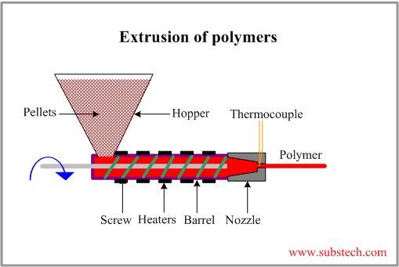
Extrusion is a process of manufacturing long products of constant cross-section (rods, sheets, pipes, films, wire insulation coating) forcing soften polymer through a die with an opening.
Polymer material in form of pellets is fed into an extruder through a hopper. The material is then conveyed forward by a feeding screw and forced through a die, converting to continuous polymer product.
Most screws have three zones:
- Feed zone. This zone feeds the resin into the extruder.
- Melting zone. Most of the resin is melted in this section.
- Metering zone. This zone melts the last particles and mixes to a uniform temperature and composition.
Heating elements, placed over the barrel, soften and melt the polymer. The temperature of the material is controlled by thermocouples.
The product going out of the die is cooled by blown air or in water bath.
Extrusion of polymers (in contrast to extrusion of metals) is continuous process lasting as long as raw pellets are supplied.
Extrusion is used mainly for Thermoplastics
Ref: Dr. Dmitri Kopeliovich http://www.substech.com/dokuwiki/doku.php?id=extrusion_of_polymers

Injection molding of polymers
A principal scheme of an Injection Molding Machine is shown in the picture.
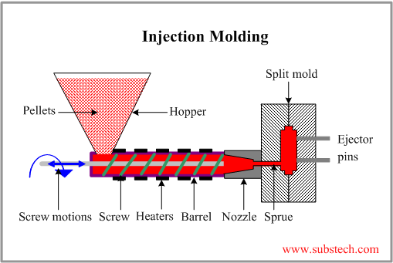
Injection Molding is a process in which molten polymer is forced under high pressure into a mold cavity through an opening (sprue).
Polymer material in form of pellets is fed into an Injection Molding machine through a hopper. The material is then conveyed forward by a feeding screw and forced into a split mold, filling its cavity through a feeding system with sprue gate and runners.
Injection Molding machine is similar to Extruder. The main difference between the two machines is in screw operation. In extruder screw rotates continuously providing output of continuous long product (pipe, rod, sheet). Screw of injection molding machine is called reciprocating screw since it not only rotates but also moves forward and backward according to the steps of the molding cycle.
It acts as a ram in the filling step when the molten polymer is injected into the mold and then it retracts backward in the molding step.
Heating elements, placed over the barrel, soften and melt the polymer.
The mold is equipped with a cooling system providing controlled cooling and solidification of the material.
The polymer is held in the mold until solidification and then the mold opens and the part is removed from the mold by ejector pins.
Injection Molding is used mainly for Thermoplastics, but Elastomers and Thermosets are also may be extruded.
Injection Molding is highly productive method providing high accuracy and control of shape of the manufactured parts. The method is profitable in mass production of large number of identical parts.
Injection Molding is used for manufacturing DVDs, pipe fittings, battery casings, toothbrush bases, disposable razors, automobile bumpers and dash boards, television cabinets, electrical switches, telephone handsets, automotive power brake, transmission, and electrical parts, toilet seats, cell-phone housings, case of a notebook-computer, computer mouse, electrical connector housings, automotive ashtrays, and cookware appliance handles and knobs, aerosol caps, household items, bottle caps, toys.
Ref: Dr. Dmitri Kopeliovich http://www.substech.com/dokuwiki/doku.php?id=extrusion_of_polymers

Blow molding
Dr. Dmitri Kopeliovich
Blow Molding is a process in which a heated hollow thermoplastic tube (parison) is inflated into a closed mold conforming the shape of the mold cavity.
The most widely used materials for Blow Molding are:
- Low Density Polyethylene (LDPE), High Density Polyethylene (HDPE)
- Polypropylene (PP)
- Polyvinyl Chloride (PVC)
- Polyethylene Terephtalate (PET)
Disposable containers of various sizes and shapes, drums, recyclable bottles, automotive fuel tanks, storage tanks, globe light fixtures, toys, tubs, small boats are produced by Blow Molding method.
There are three principal techniques of Blow Molding, differing in the method by which parisons are prepared:
- Extrusion Blow Molding
- Injection Blow Molding
- Stretch Blow Molding

Extrusion Blow Molding
Extrusion Blow Molding involves manufacture of parison by conventional extrusion method using a die similar to that used for extrusion pipes.
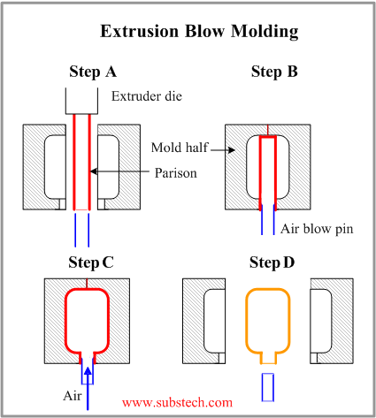
Extrusion Blow Molding is commonly used for mass production of plastic bottles.
The production cycle consists of the following steps:
- The parison is extruded vertically in downward direction between two mold halves.
- When the parison reaches the required length the two mold halves close resulting in pinching the top of parison end and sealing the blow pin in the bottom of the parison end.
- Parison is inflated by air blown through the blow pin, taking a shape conforming that of the mold cavity. The parison is then cut on the top.
- The mold cools down, its halves open, and the final part is removed.
to top

Injection Blow Molding
In Injection Blow Molding method a parison is produced by injecting a polymer into a hot injection mold around a blow tube or core rod.
Then the blow tube together with the parison is removed from the injection mold and transferred to a blow mold.
Following operations are similar to those in the extrusion blowing molding.
Injection Blow Molding is more accurate and controllable process as compared to the Extrusion Blow Molding.
It allows producing more complicated products from a wider range of polymer materials.
However production rate of Injection Blow Molding method is lower than that of Extrusion Blow Molding.
to top

Stretch Blow Molding
Stretch Blow Molding is similar to Injection Plow Molding.
Stretch Blow Molding involves injection molding of a parison, which is then stretched in the downward direction by means of the blow tube.
The extended parison is then inflated in a blow mold.
In this method biaxial molecular orientation is produced. The specific molecular orientation provides higher mechanical strength, rigidity and transparency of the material.
Material, commonly used in this method is Polyethylene Terephtalate (PET).
Stretch Blow Molding is used for manufacturing containers for carbonated beverages.

