SLOPE
The slope of a line in the plane containing the x and y axes is generally represented by the letter m, and is defined as the change in the y coordinate divided by the corresponding change in the x coordinate, between two distinct points on the line. This is described by the following equation:
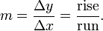
(The Greek letter delta "Δ", is commonly used in mathematics to mean "difference" or "change".)
Given two points (x₁,y₁) and (x₂,y₂), the change in x from one to the other is x₂ − x₁ (run), while the change in y is y₂ − y₁ (rise). Substituting both quantities into the above equation generates the formula:
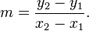
The formula fails for a vertical line, parallel to the y axis, where the slope can be taken as infinite, so the slope of a vertical line is considered undefined.
FACTORIAL
In mathematics, the factorial of a non-negative integer n, denoted by n!, is the product of all positive integers less than or equal to n. For example,

Limit of a function
Suppose f(x) is a real-valued function and c is a real number. The expression
means that f(x) can be made to be as close to L as desired by making x sufficiently close to c. In that case, the above equation can be read as "the limit of f of x, as x approaches c, is L".
Differentiation is a method to compute the rate at which a dependent output y changes with respect to the change in the independent input x. This rate of change is called the derivative of y with respect to x. In more precise language, the dependence of y upon x means that y is a function of x. This functional relationship is often denoted y = f(x), where f denotes the function. If x and y are real numbers, and if the graph of y is plotted against x, the derivative measures the slope of this graph at each point.
The simplest case is when y is a linear function of x, meaning that the graph of y divided by x is a straight line. In this case, y = f(x) = m x + b, for real numbers m and b, and the slope m is given by
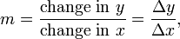
where the symbol Δ (the uppercase form of the Greek letter Delta) is an abbreviation for "change in."

In Leibniz's notation, such an infinitesimal change in x is denoted by dx, and the derivative of y with respect to x is written
suggesting the ratio of two infinitesimal quantities. The above expression is read as "the derivative of y with respect to x", "d y by d x", or "d y over d x".

Solving Simple Differential Equations
These are equations where dy/dx is in terms of x.
In these situations we just use regular integration to find the original equation.
Example:
Find the equation of the graph whose gradient,
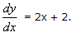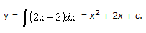

General and Particular Solutions
Having done our integration we get an expression that includes the constant '+ c'.
If we know one point we can find c, and this will give us a particular solution.
If we do not know a point on the graph then we cannot find c and we get a general solution.
General Solutions
In the example above we found a general solution y = x² + 2x + c. To illustrate a general solution we draw a family of curves on a coordinate grid, each graph representing a different value for c. The family of curves for y = x² + 2x + c is:
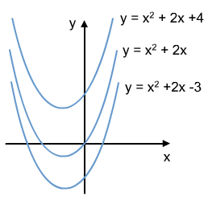
Particular Solutions
A Particular Solution, (or Particular Integral), is a specific solution to the question that is found using an extra piece of information - one point that lies on the graph.
For instance, if the graph y = x² + 2x + c contains the point (-2, 3), then we know that when x = -2, y = 3.
This gives us:
4 − 4 + c = 3
Therefore:
c = 3 and the particular solution is y = x² + 2x + 3.

