Rotational Molding

A premeasured amount of powdered or liquid plastic is placed in mold half. The mold is closed, transferred to the heating oven, and then on to the cooling station. During the entire heating and cooling process, the molds simultaneously rotate around two right-angle axes.

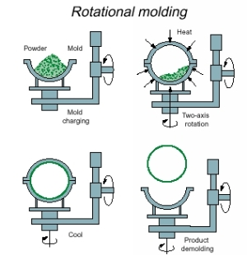
Typical rotationalmolding machine with three arms that rotate between loading/unloading stations, heating ovens, and cooling chambers.

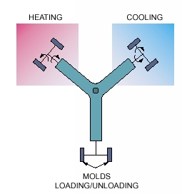
In their simplest form, rotomolding machines have three arms that rotate between loading/unloading stations, heating ovens, and cooling chambers. Molds made from either sheet metal or cast aluminum mount on each arm. A premeasured amount of powdered or liquid plastic goes in half the mold. The mold then closes and the arm moves it into the heating oven.
Inside the oven, the molds simultaneously rotate around two right-angle axes. Heat fuses the resin into uniform layers on mold surfaces. The amount of resin added controls wall thickness. The rotating molds then move to the cooling chamber. As a combination of air and water cools the molds the plastic solidifies.
Parts made from different grades of polyethylene (PE) dominate the rotomolding market. The most common grade of PE is linear low density (LLDPE). Others include high-density (HDPE), cross-linked (XPE), and ethylene-vinyl-acetate (EVA) copolymers. Polyvinylchloride (PVC) was the original material used for rotational molding and is probably the second most common material. It can be either liquid or powder and comes in a wide variety of durometers. Thermoplastics such as nylon, polycarbonate (PC), or polypropylene (PP) generally give better heat resistance, tensile strength, and stiffness than PE.
Rotomolding is known for providing design flexibility, low-cost tooling, and stress-free parts. Its disadvantages, however, include higher part cost, fewer material choices compared to other processes, and slower production.

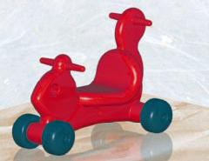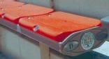
Football enthusiasts now sit on rotationally molded bench seats. Designed by Dant Clayton Corp., Louisville, Ky., the plastic seats were installed in 1999 in the Citrus Bowl, Orlando, Fla. Normally with a volume requirement of 65,000 one would consider the blow-molding process. But the project required seven different sized seats each in three different colors. The blow-mold tooling would have been more expensive and the production runs for each size/color combination would have been small for the blow-molding process.

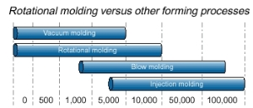

Rotationally molded products are a good fit for a wide range of industries. Production runs up to 10,000 units maybe suitable for rotational molding.

REF: http://machinedesign.com/plastics-and-composites/putting-right-spin-rotational-molding-designs

