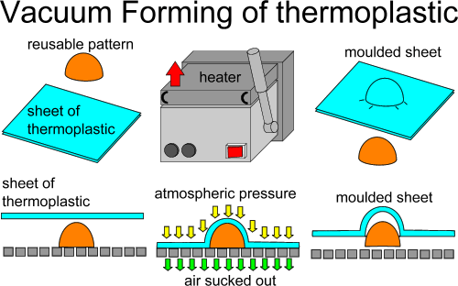
Vacuum forming uses thin sheets of thermoplastic.
A mould is created from wood or epoxy resin and this is placed on the table (platten) of the vacuum forming machine. The sheet plastic is heated until it becomes soft. Vacuum is used to draw the plastic over the mould.
The plastic can then be trimmed to the required shape.

